**OVERVIEW**

1. Download software prerequisites
2. Define domain geometry and generate mesh
3. Create transient hydrologic boundary conditions (.bcvs) file
4. Create transient geochemical boundary conditions block
5. Amend databases and run model

**1. SOFTWARE PREREQUISITES**

**MIN3P**

<https://eilinator.eos.ubc.ca:8443/index.php/s/5t8bXDnvfUAlPRF>

Select the Download button at the top-right corner.

Note: I extracted the folder into my C: drive and renamed the folder “MIN3P”.

**Microsoft Visual Studio 2019**

<https://visualstudio.microsoft.com/>

Download Visual Studio Community 2019.

When you run the installer, there will be a window that asks you which Workloads you would like to download; before clicking Install, check the box next to “Desktop development with C++” under Desktop & Mobile. This should take up about 7.4 Gb if you do not already have Visual Studio installed.

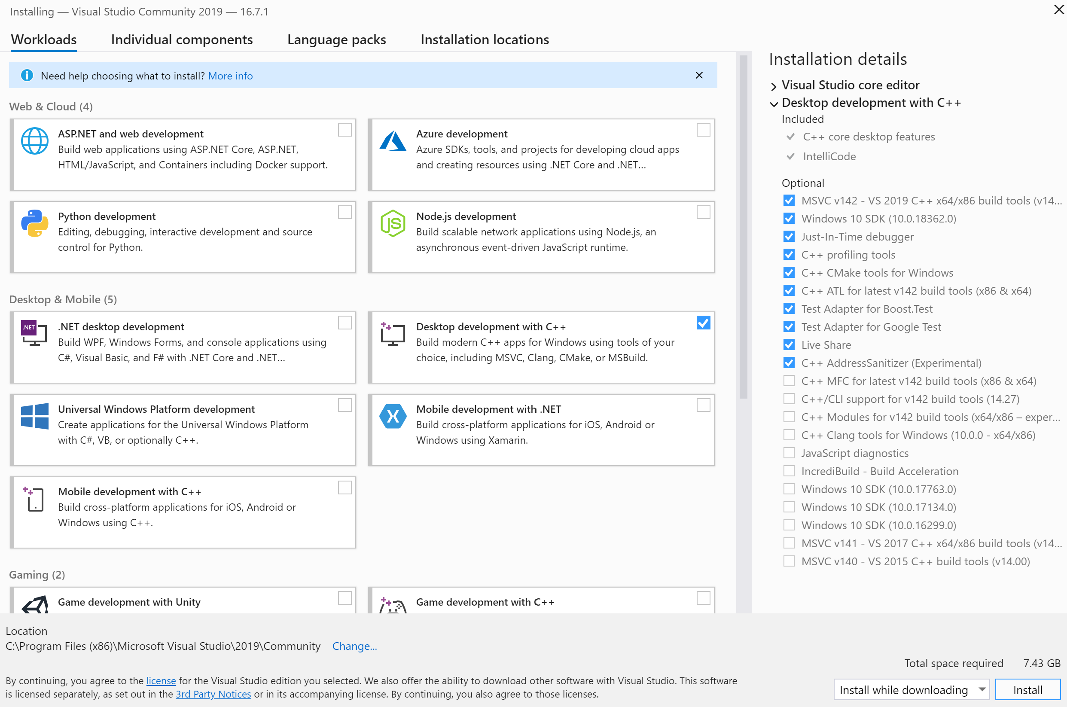

**Intel Parallel Studio XE**

[http://software.intel.com/en-us/articles/redistributable-libraries-for-intel-c-and-visual- fortran-composer-xe-2013-for-windows](http://software.intel.com/en-us/articles/redistributable-libraries-for-intel-c-and-visual-%20fortran-composer-xe-2013-for-windows)

Go to the Intel Developer Zone drop down menu in top-left corner > Development tools > Intel Parallel Studio XE > Download the Full Package.

Follow the installation process, keeping all default settings.

After installing Intel Parallel Studio XE, go to Command Prompt and paste following commands (this assumes Parallel Studio was installed by default into the directory given below; change path as needed):

cd C:\Program Files (x86)\IntelSWTools\parallel_studio_xe_2020.2.899\bin

psxevars.bat intel64

**Gmsh and Software Development Kit (SDK)**

[http://gmsh.info](http://gmsh.info/)

Download Gmsh for Windows 64-bit and the SDK for Windows 64-bit

Extract files into any folder.

Access application through Gmsh folder (gmsh-4.6.0-Windows64 by default).

**HYDRUS-1D**

<https://www.pc-progress.com/en/Default.aspx?H1d-downloads>

You will be prompted to register, but it takes less than a minute.

**2. MESH GENERATION**

*Note: The following tasks can be performed using a .geo file, the command line, and/or the Gmsh GUI. I use a .geo file because the GUI can be tedious.*

1. **Create geometry**; performing steps 1.2-1.6 will create a 2D rectangular domain, with an optional additional step (1.7) to extrude the 2D domain into a 3D prism.
   1. Basic command syntax and terminology
      * Each point, line, surface, and volume is an individual **entity**
      * Each entity within a type (e.g. point) needs to have a **unique tag** (e.g. 1, 2, 3, etc.)
      * To comment use “//”
      * To end a command use “;”
   2. Create a blank .txt file, which will later be saved as a .geo file. Each of the commands in steps 1.3-1.7 will be a new line in the .txt file.
   3. Define points using the “Point” command (only define points necessary to create the basic geometric shape, e.g. a rectangle will need four points defined).
      * Syntax: Point(*tag*) = {*x*, *y*, *z*, *size*};
      * Example: Point(3) = {0, 0, 1, 1.0);
      * Note: Size is 1.0 by default
   4. Define lines using the “Line” command.
      * Syntax: Line(*tag*) = {*startPoint*, *endPoint*};
      * Example: Line (9) = {1, 2}
   5. Define a closed system of lines using the “Curve Loop” command; this is a prerequisite for creating a planar surface.
      * Syntax: Curve Loop(*tag*) = {*list of lines*};
      * Example: Curve Loop(9) = {5, 6, 7, 8}
      * Note: The sequence within the list of lines matters, as do the start and end points of each line. The start point of each line within the sequence should correspond to the end point of the line immediately prior in the sequence. You can use “negative” lines (i.e. -5) if the start and end point for any of your lines is backwards.
   6. Define surfaces using the “Plane Surface” command.
      * Syntax: Plane Surface(*tag*) = {*list of lines*};
      * Example: Plane Surface(21) = {9, 10, 11, 12};
   7. Extrude the plane surface to create a volume.
      * Syntax: Volume(*tag*) = {*list of plane surfaces*};
      * Example: Volume(27) = {21, 22, 23, 24, 25 26);
2. **Generate mesh**
   1. Specify mesh size as a function of spatial coordinates using the “Field” command
      * Syntax: Field[*tag*] = *fieldType*;
      * Example: Field[1] = MathEval;
   2. Define function
      * Syntax: Field[*tag*].F = “*function*”;
      * Example: Field[1].F = “(-z + 6) / 20”;
      * Note 1: There are several ways to define mesh sizes, see the manual for all options. I use MathEval because you can create variable mesh sizes, or you can define the equation as a constant to create uniform mesh sizes.
      * Note 2: You can define multiple fields and Gmsh will overlay them and choose the smallest mesh size for each cell. You may want to use this if there is a specific point that needs very high resolution.
   3. Set background field using “Background Field” command
      * Syntax: Background Field = *field*;
      * Example: Background Field = 1;
   4. Generate mesh using “Mesh” command
      * Syntax: Mesh *numberOfDimensions*;
      * Example: Mesh 3;
3. Save mesh as .vtk file by going to File > Export
4. When saving the mesh as a .geo file, File > Save Mesh does not allow you to choose where to save it. Instead, go to File > Rename.

**3. TRANSIENT HYDROLOGIC BOUNDARY CONDITIONS (.BCVS) FILE**

1. **Create first HYDRUS-1D model**, which will provide ponding depth and infiltration rates due to rainfall and evapotranspiration
   1. Create new HYDRUS-1D file
      1. Open HYDRUS-1D and go to File > New
      2. Choose Name (e.g. PondingDepth_M1B1)
      3. Set Directory to Tutorial directory
   2. Choose/define parameters
      1. Main Processes
         * Make sure only “Water Flow” is checked
      2. Geometry Information
         * “Length Units” = m
         * “Number of Soil Materials” = 2
         * “Number of Layers for Mass Balances” = 1
         * “Decline from Vertical Axes” = 1
         * “Depth of Soil Profile [m]” = 5
      3. Time Information
         * “Time Units” = Minutes
         * “Initial Time [min]” = 0
         * “Final Time [min]” = 44640
         * “Initial Time Step [min]” = 0.01
         * “Minimum Time Step [min]” = 0.01
         * “Maximum Time Step [min]” = 15
         * Make sure “Time-Variable Boundary Conditions” is checked
         * “Number of Time-Variable Boundary Records” = 2973
      4. Print Information
         * Make sure “T-Level Information” is checked
         * “Every n time steps” = 1
         * Make sure “Screen Output”, “Print Fluxes”, and “Hit Enter at End?” are checked
         * “Number of Print Times” = 1
         * Click “Next” and set “Print Times [min]” to 44640
      5. Iteration Criteria (I think these are the default values)
         * “Maximum Number of Iterations” = 100
         * “Water Content Tolerance” = 0.001
         * “Pressure Head Tolerance [m]” = 0.01
         * “Lower Optimal Iteration Range” = 3
         * “Upper Optimal Iteration Range” = 7
         * “Lower Time Step Multiplication Factor” = 1.3
         * “Upper Time Step Multiplication Factor” = 0.7
         * “Lower Limit of the Tension Interval [m]” = 1e-008
         * “Upper Limit of the Tension Interval [m]” = 100
      6. Soil Hydraulic Model
         * Select “van Genuchten – Mualem” and check “With Air-Entry Value of -2 cm”
         * Make sure nothing is selected under “Dual-Porosity/Dual-Permeability Models”
         * Select “No hysteresis”
      7. Soil Hydraulic Parameters

|  |  |  |  |  |  |  |
| --- | --- | --- | --- | --- | --- | --- |
| Mat | Qr [-] | Qs [-] | Alpha [1/m] | n [-] | Ks [m/min] | l [-] |
| 1 | 0.2 | 0.45 | 2 | 1.35 | 3E-006 | 0.5 |
| 2 | 0.11 | 0.5 | 2.5 | 1.15 | 3E-005 | 0.5 |

* + 1. Water Flow Boundary Conditions
       - “Upper Boundary Condition”: Check “Atmospheric BC with Surface Layer”
       - “Lower Boundary Condition”: Check “Variable Pressure Head”
       - “Initial Condition”: Check “In Pressure Heads”
       - “Max h at Soil Surface” = 100
    2. Skip Time Variable Boundary Conditions
    3. Do not run the Soil Profile Graphical Editor (PROFILE Application)
    4. Soil Profile Summary
       - In the “Mat” column, assign “1” to the upper 1 m and “2” to the lower 4 m
         * This will assign the Soil Hydraulic Parameters defined previously to the appropriate cells
         * Tip: Enter 1 in the first row, then select that cell and drag it down to assign 1 to the upper 1 m
  1. Save the model and close HYDRUS
  2. Create ATMOSPH.IN file for HYDRUS model
     1. Refer to R script “HYDRUS_Input_1.R”
     2. Make sure a new ATMOSPH.IN file was created in the PondingDepth_M1B1 folder
  3. Launch HYDRUS-1D, open your model, and run the HYDRUS-1D application

1. **Create second HYDRUS-1D model**, which will provide infiltration rates due to rainfall and bankfull overflow
   1. Copy PondingDepth_M1B1 folder and H1D file within tutorial folder; rename the copied folder and file to InfilRate_M1B1
   2. Open InfilRate_M1B1 in HYDRUS-1D
      1. Click on “Water Flow – Boundary Conditions”
      2. Change “Upper Boundary Condition” from “Atmospheric BC with Surface Layer” to “Variable Pressure Head”
   3. Save the model and close HYDRUS
   4. Create ATMOSPH.IN file for HYDRUS model
      * Refer to R script “HYDRUS_Input_2.R”
      * Make sure a new ATMOSPH.IN file was created in the InfilRate_M1B1 folder
2. **Create boundary conditions file** (ERRH2D.bcvs)
   * Refer to R script “transientVSFBCs.R”

**4. TRANSIENT GEOCHEMICAL BOUNDARY CONDITIONS BLOCK**

1. Create blocks for geochemical boundary conditions
   * Refer to R script “transientRTBCs.R”
2. Copy and paste contents of “rtbc.txt” into end of .dat file.

**5. AMEND DATABASES AND RUN MODEL**

1. Copy Tutorial > ERRH_db folder into MIN3P > Examples > database
   * Includes amendments to redox.dbs and minerals.dbs
2. Run Tutorial > MIN3P > ERRH.bat

**TROUBLESHOOTING**

If there is an error window indicating that the “VCOMP100.DLL” file is missing, go to the following link: <https://www.microsoft.com/en-us/download/details.aspx?id=26999>

I deleted the following time steps in the .bcvs file after non-convergence.

14.5833333333333

14.6041666666667

14.625

25.5625

25.5833333333333

25.6041666666667